1. Configure Classic Load balancer.

Steps:

1. First we have to create two instances with two availability zones and aslo add the script to install httpd with index.html
2. Next go to Load Balancer and click on create load balancer
3. After that select Classic Load Balancer and also add these two instances to it and create
4. Next open the web page with DNS name and it will show the script what we have saved in two instances when we refresh each time

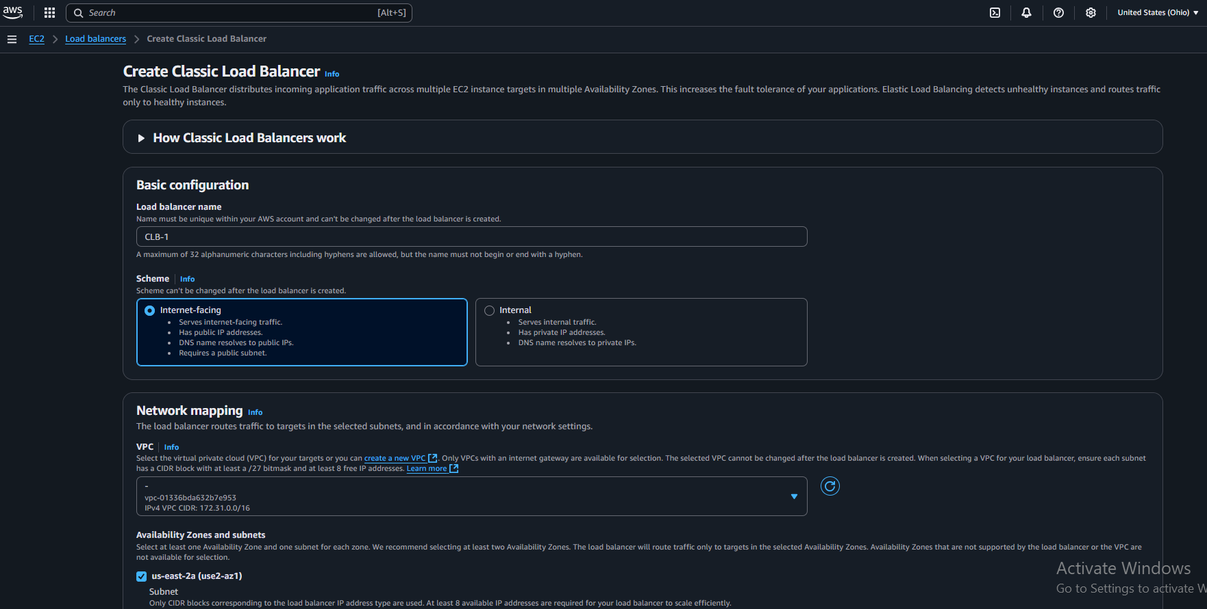

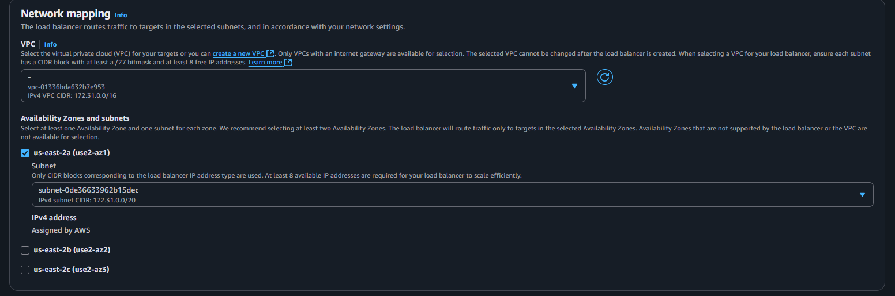

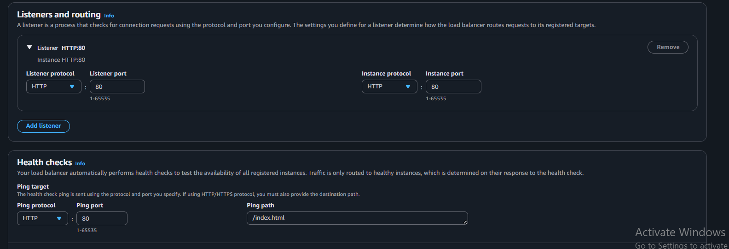

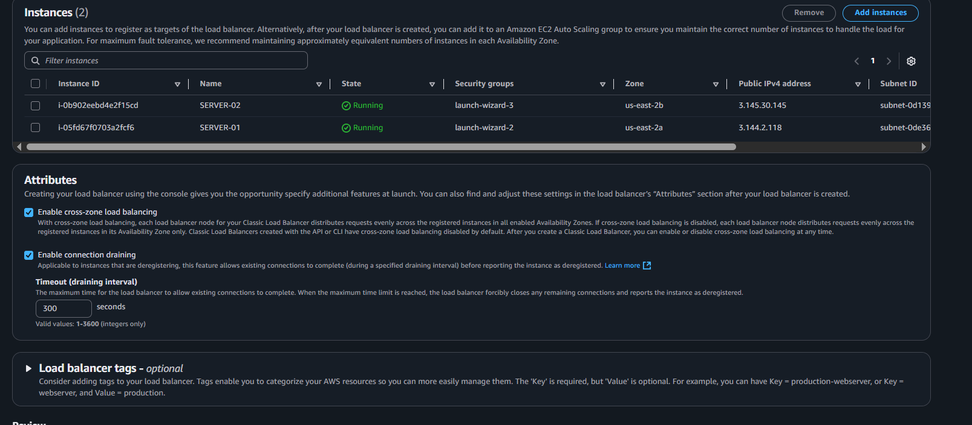

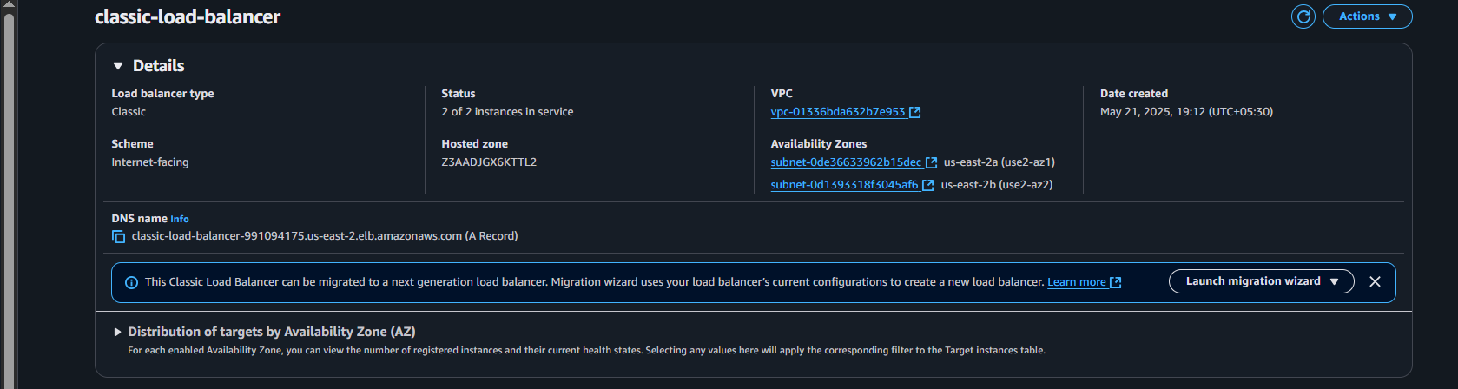



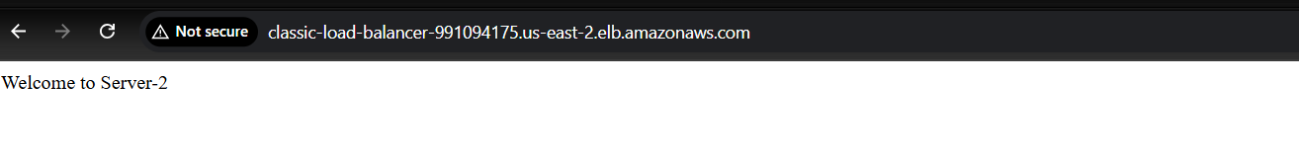

1. Configure Application Load balancer

Steps:

1. First we have to create two instances with two availability zones and aslo add the script to install httpd with index.html
2. Next go to Load Balancer and click on create load balancer
3. After that select Application Load Balancer and also add these two instances to it and create while creating before we have to create a group tragets and then we have add the instances to this
4. Next open the web page with DNS name and it will show the script what we have saved in two instances when we refresh each time

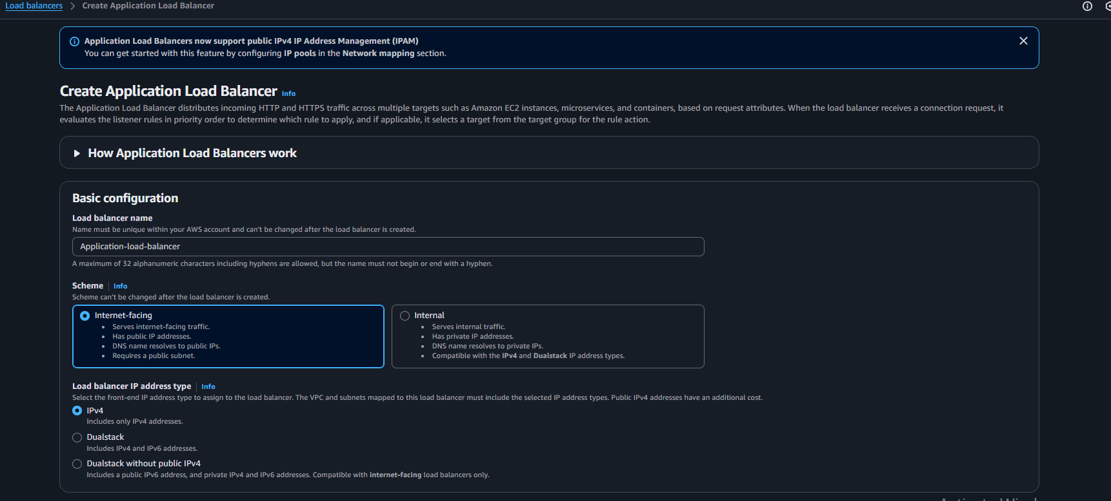

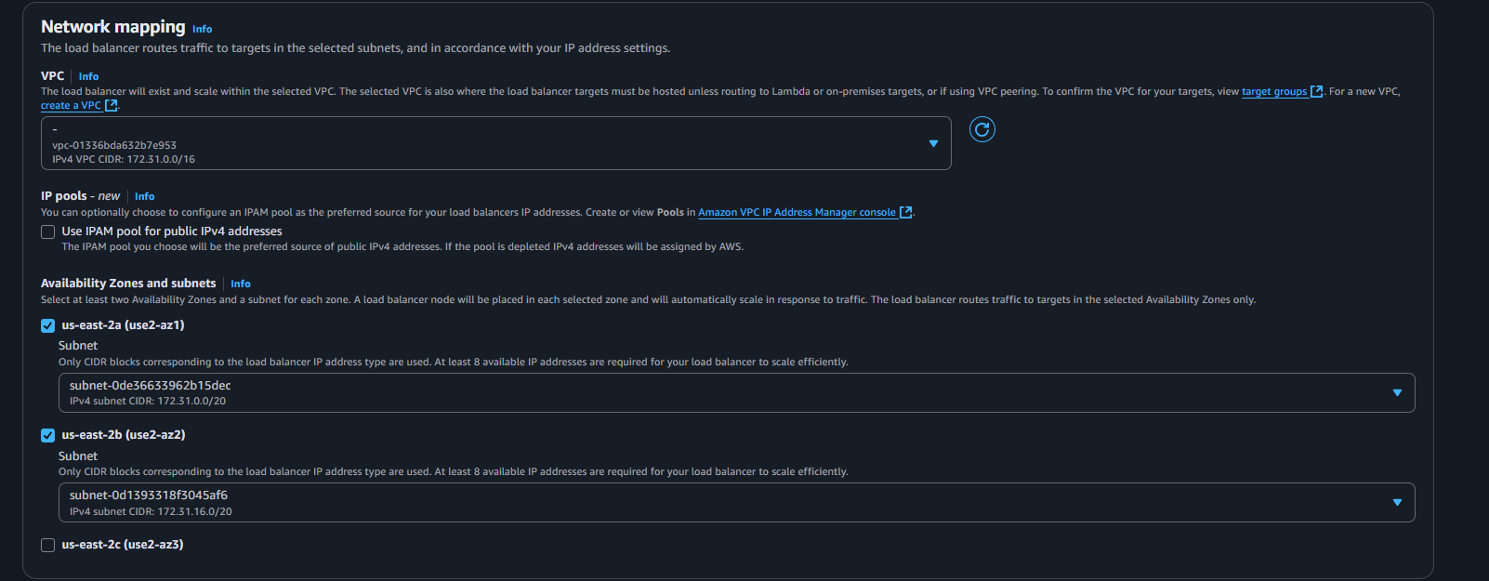

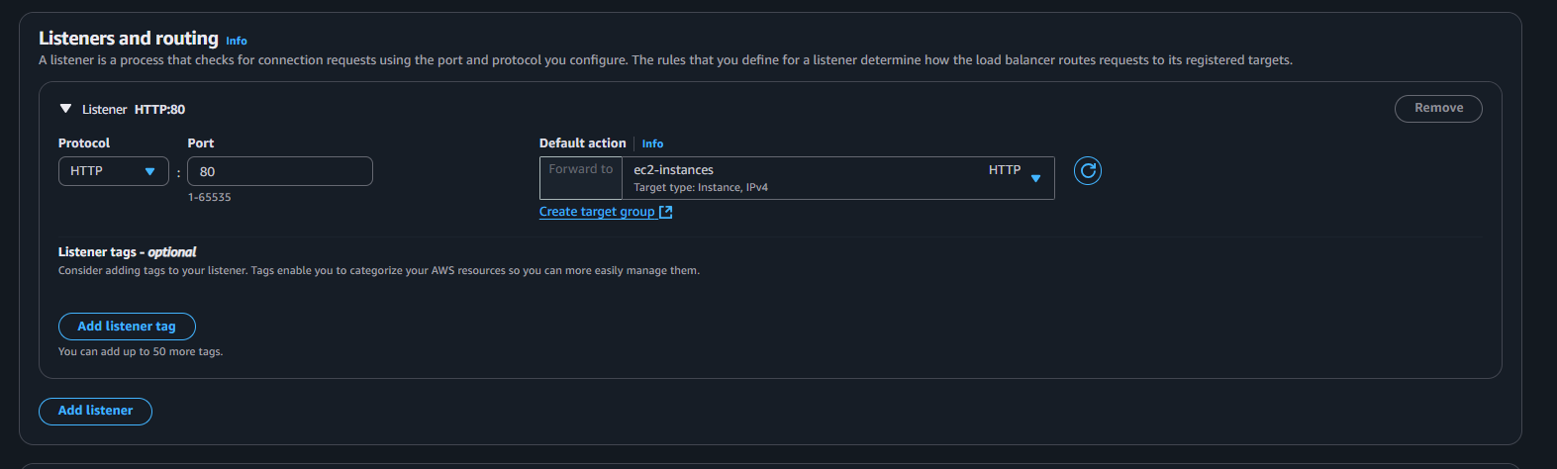

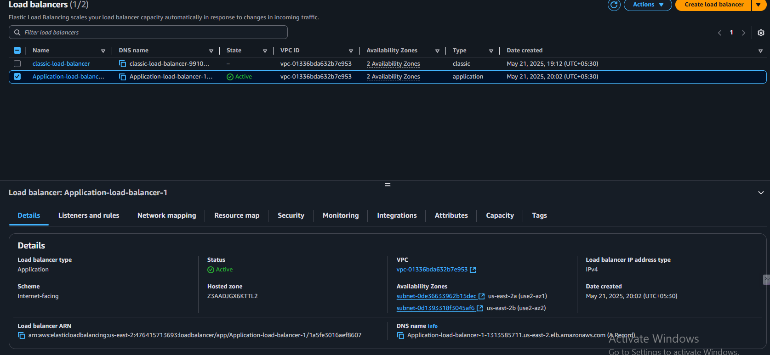

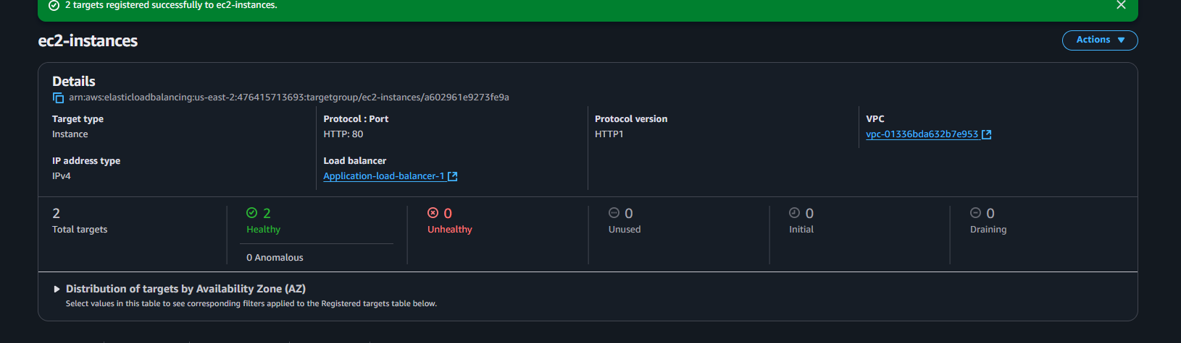

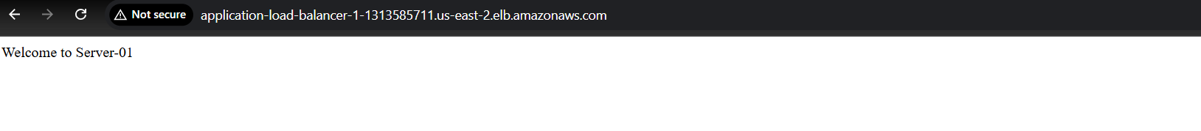

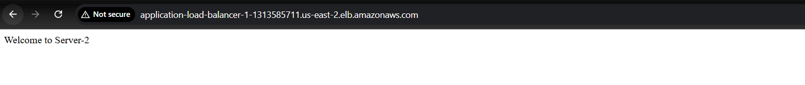

1. Configure Network Load balancer.

Steps:

1. First we have to create two instances with two availability zones and aslo add the script to install httpd with index.html
2. Next go to Load Balancer and click on create load balancer
3. After that select Network Load Balancer and also add these two instances to it and create while creating before we have to create a group tragets and then we have add the instances to this
4. Next open the web page with DNS name and it will show the script what we have saved in two instances

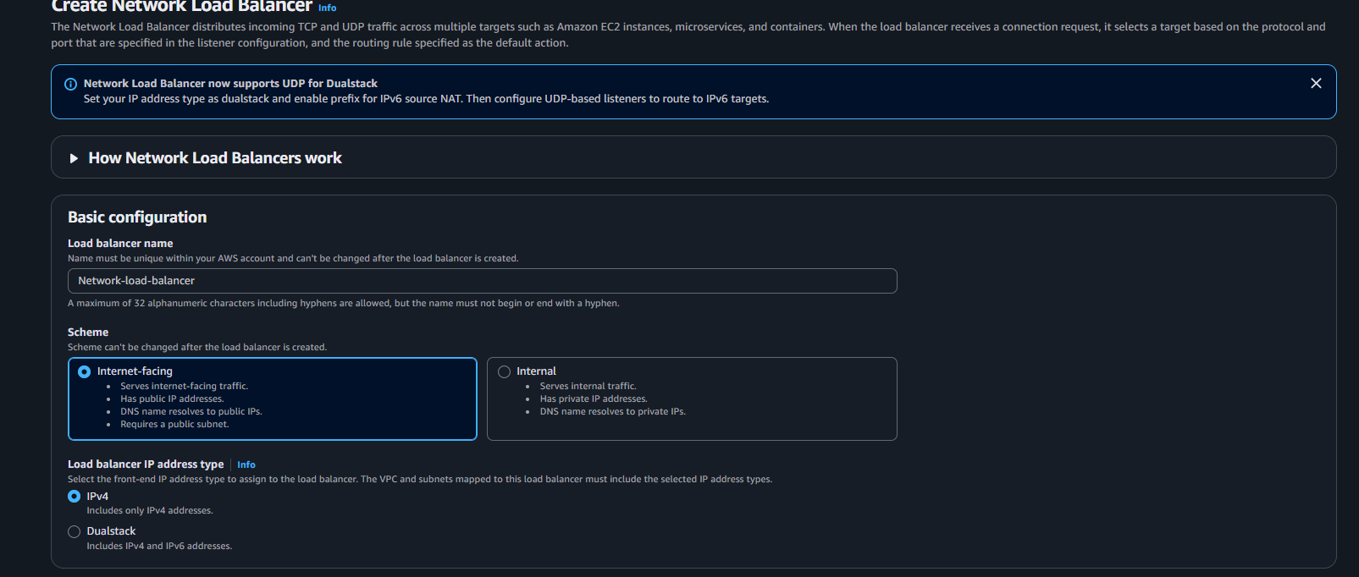

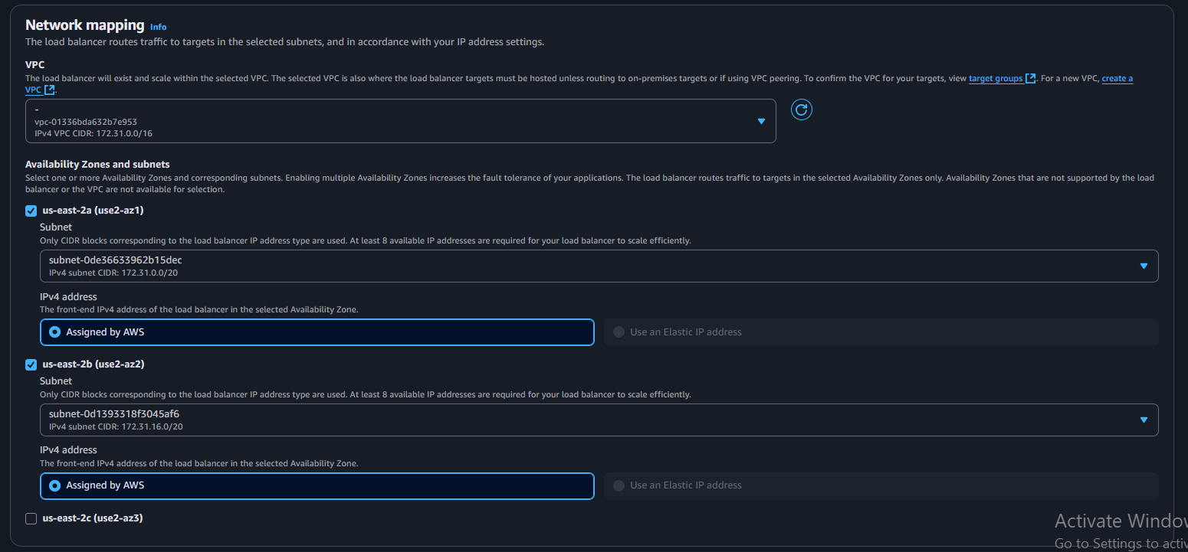

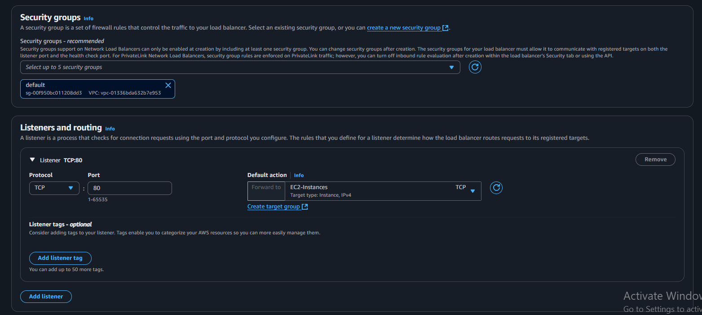



1. Attach SSL for application load balancer.
2. **Requested SSL Certificate:**
   * Domain: theshiva.shop
   * Verified using DNS
   * Status: **Issued**
3. **Created Application Load Balancer (ALB):**
   * Attached **2 EC2 instances** (both healthy)
   * Web page works on **HTTP (port 80)**

* Add **HTTPS listener (port 443)** to the ALB
* Attach your **SSL certificate**
* (Optional) Redirect HTTP to HTTPS
* Next check it with your domain theshiva.shop on webpage

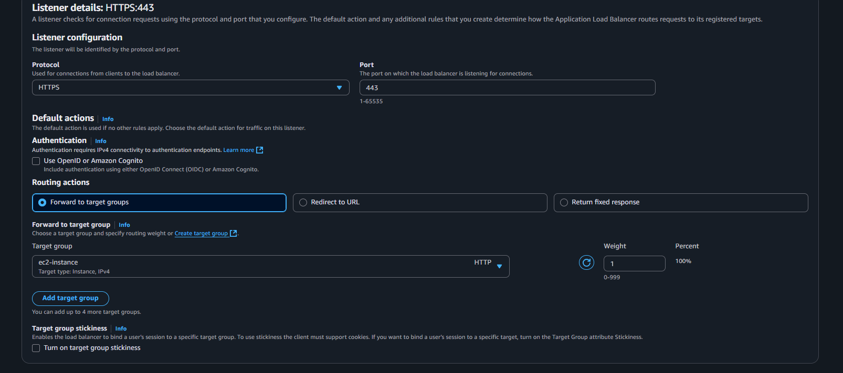

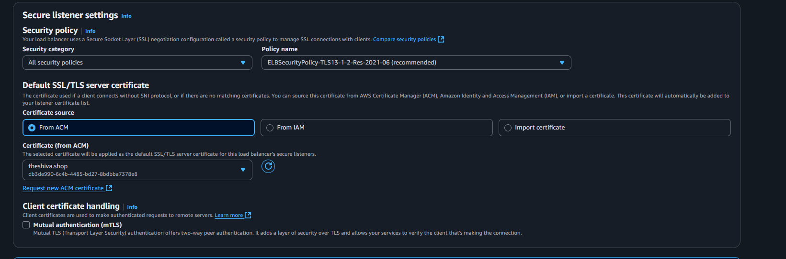

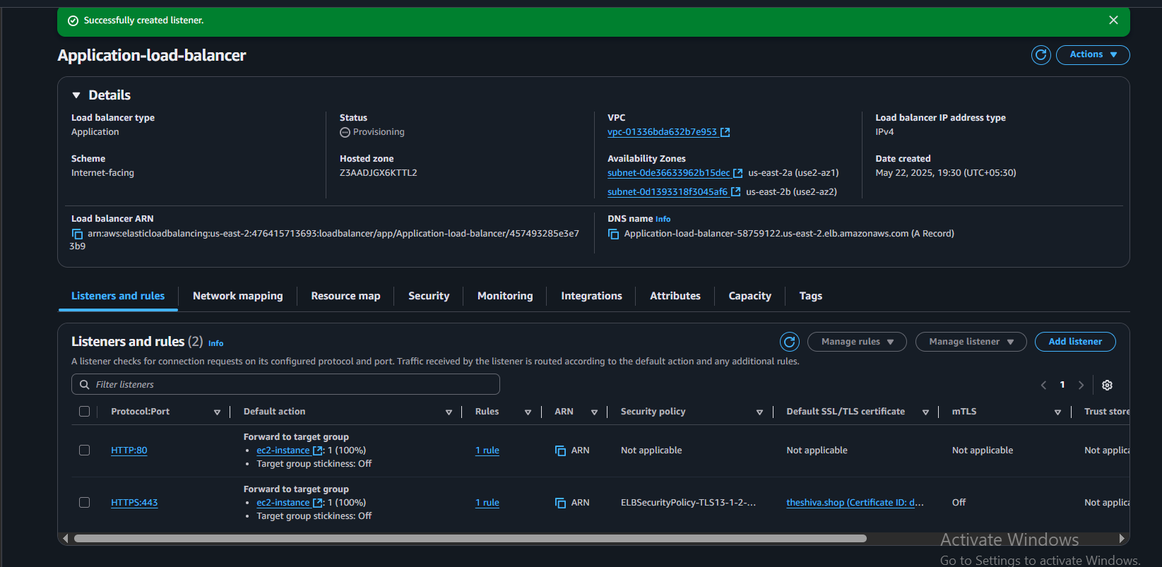



1. Map Applciation load balancer to R53.

First we have to go to route53 and create a record with required details

Next check the webpage opened or not

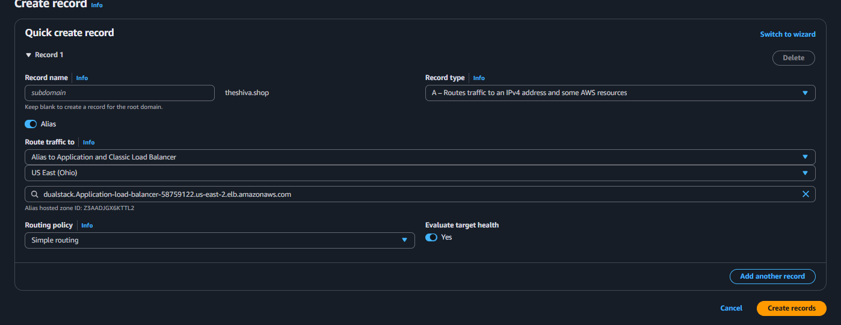

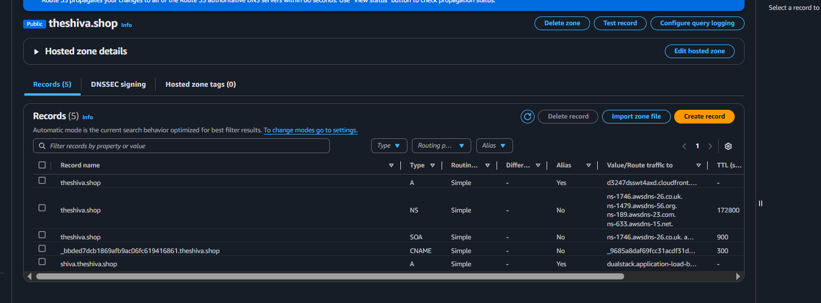

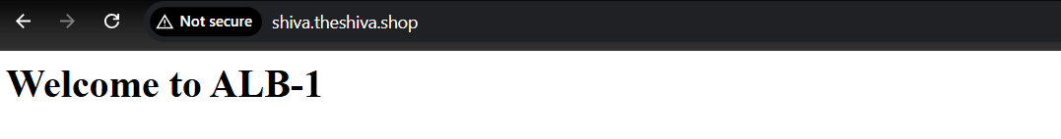

1. Push the application load balancer logs to s3.

Steps:

**Created an S3 bucket named kinger-156** in **US East (Ohio) — us-east-2** region.

**Enabled Access Logs for your Application Load Balancer (ALB)** and set the log destination to the kinger-156 bucket.

**Made sure connection logs are OFF** (optional for ALB).

**You need to add a bucket policy** to kinger-156 to allow ALB to write logs into it.

